SMIT R PATEL

19162121031

SEM 5

BDA

PRACTICAL 2

AIM- To understand the working of different basic Hadoop commands compared to Linux commands.

Tasks:

1. You are working on Hadoop system for the first time, and you need to figure out all the available

Hadoop commands and how to use them. Use the “-help” command to do this.

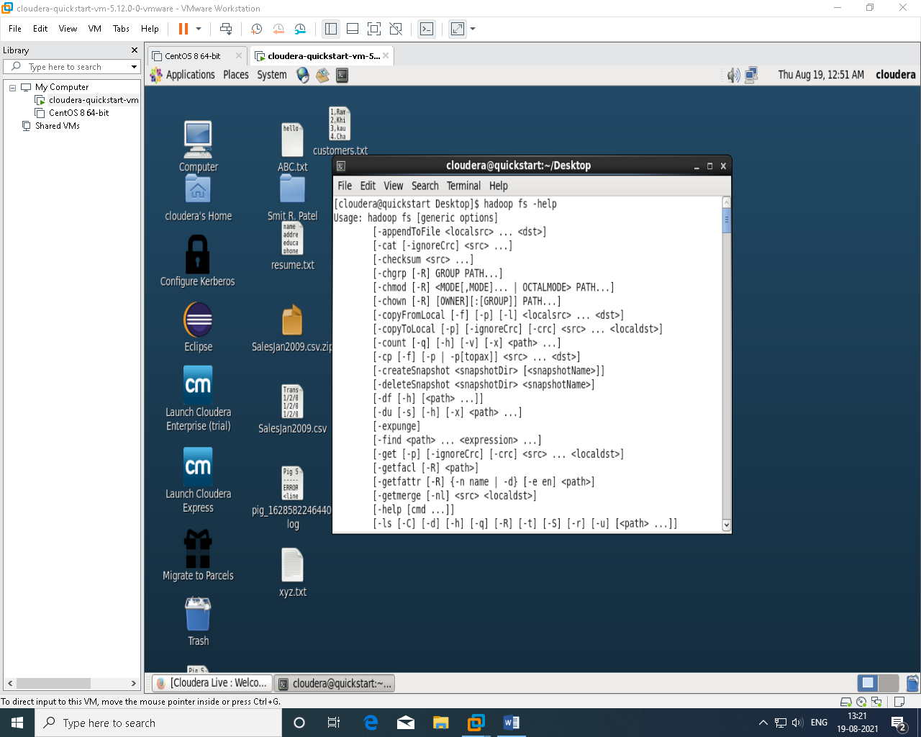

2.

A. Create directory ICT and inside that create subdirectory sem-5. Upload your resume in this folder

and display its content.

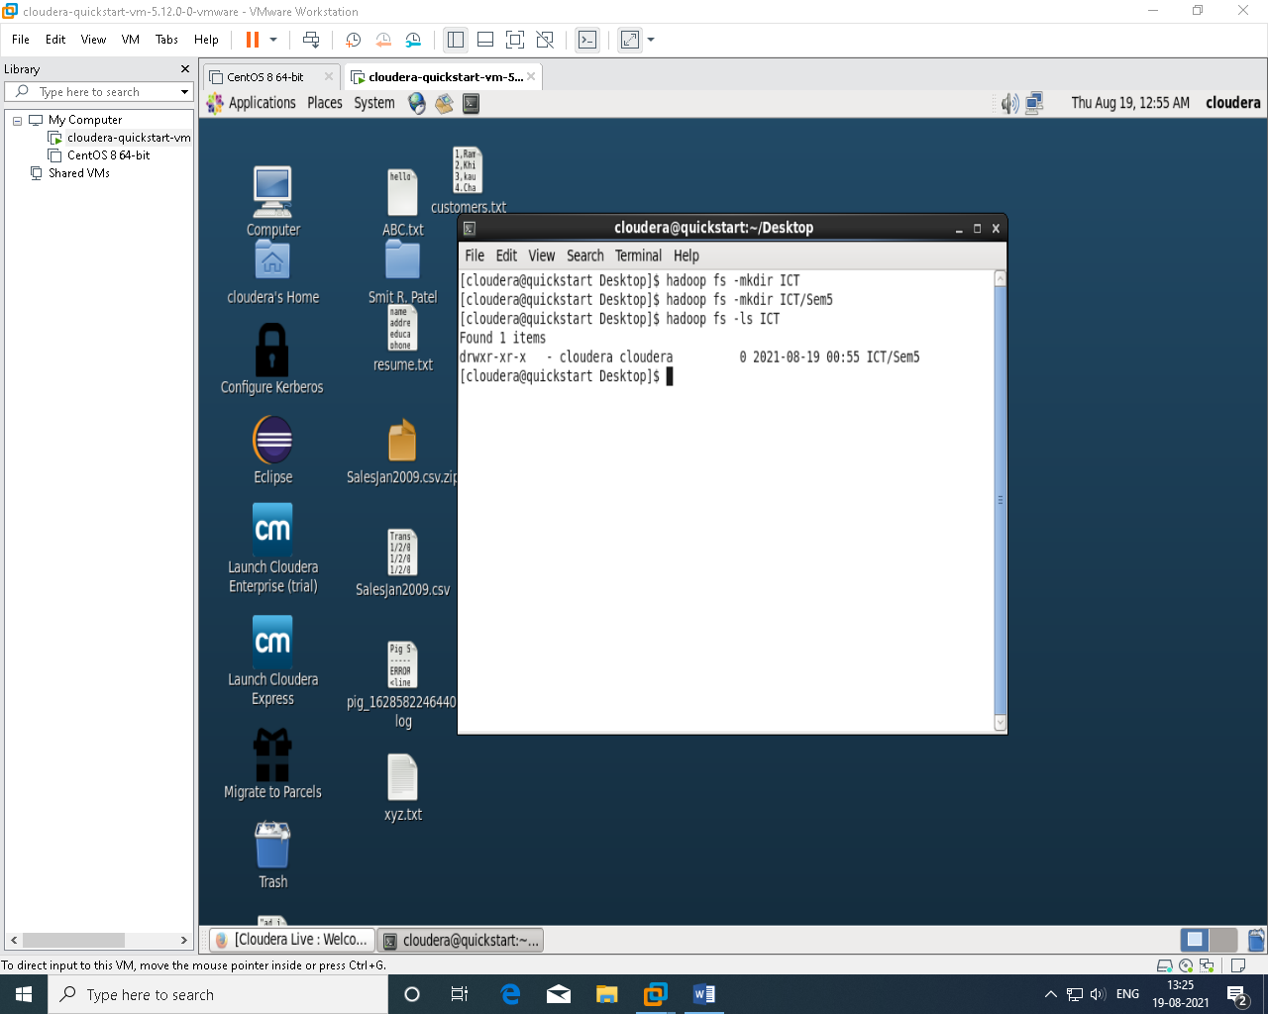

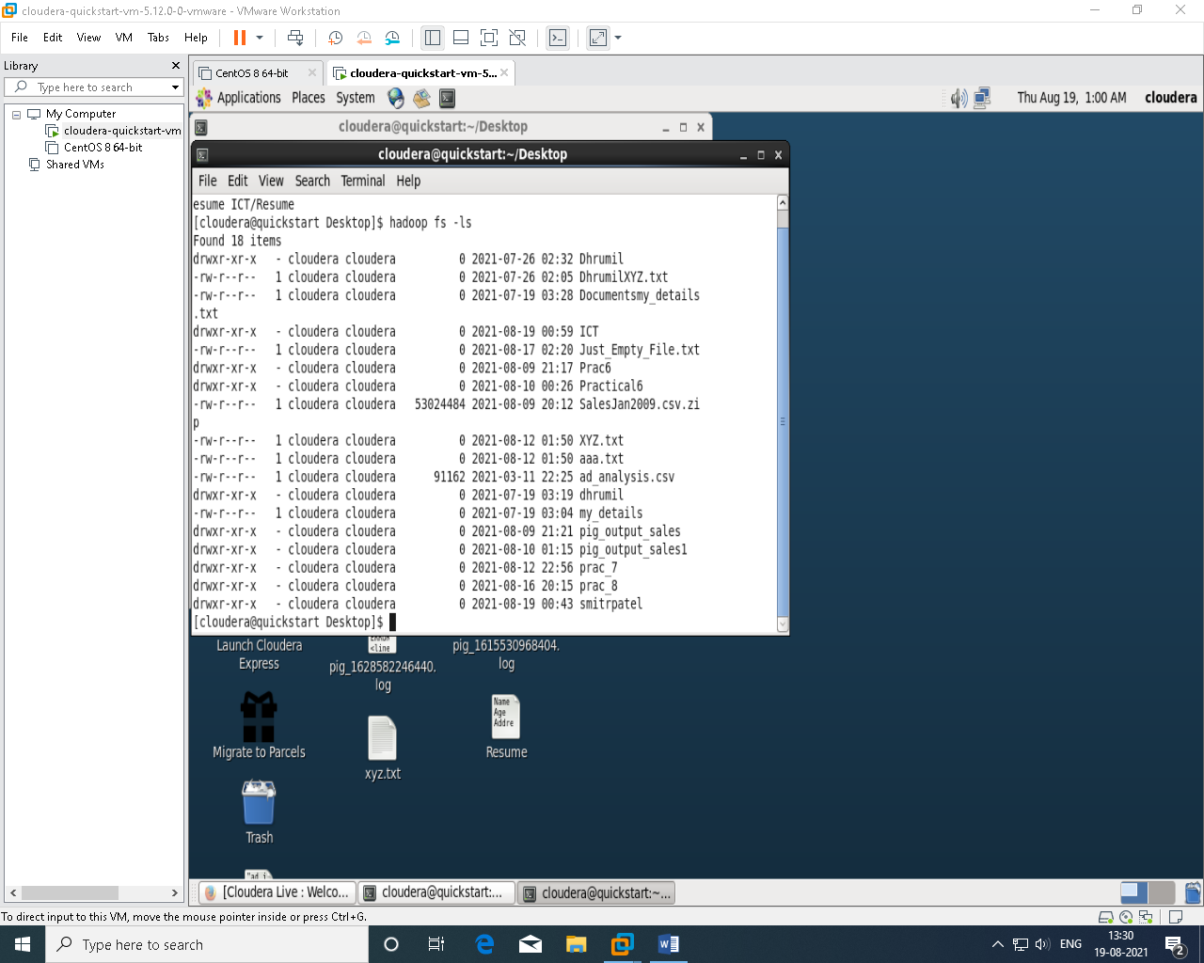

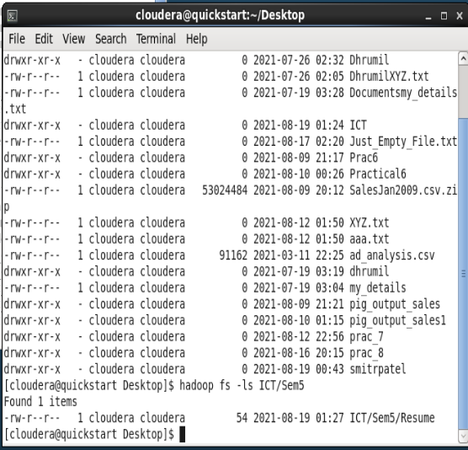

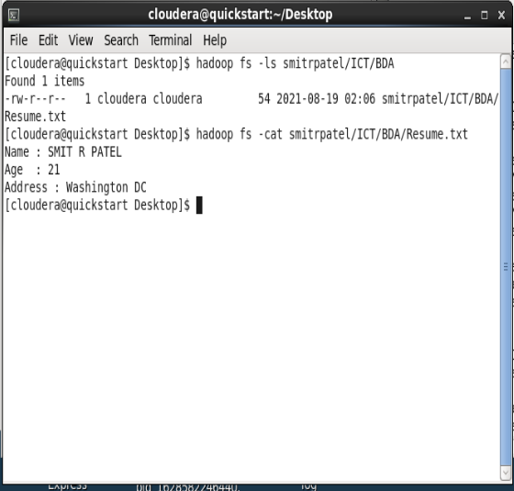

B. Create another directory <Branch> in ICT directory copy the resume in sem-5 file here, and delete

sem-5 directory.

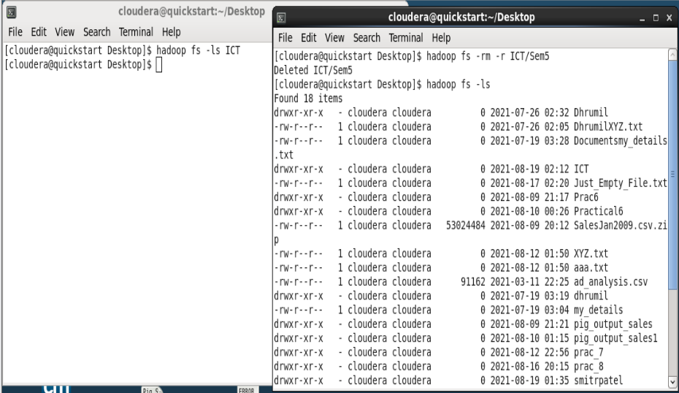

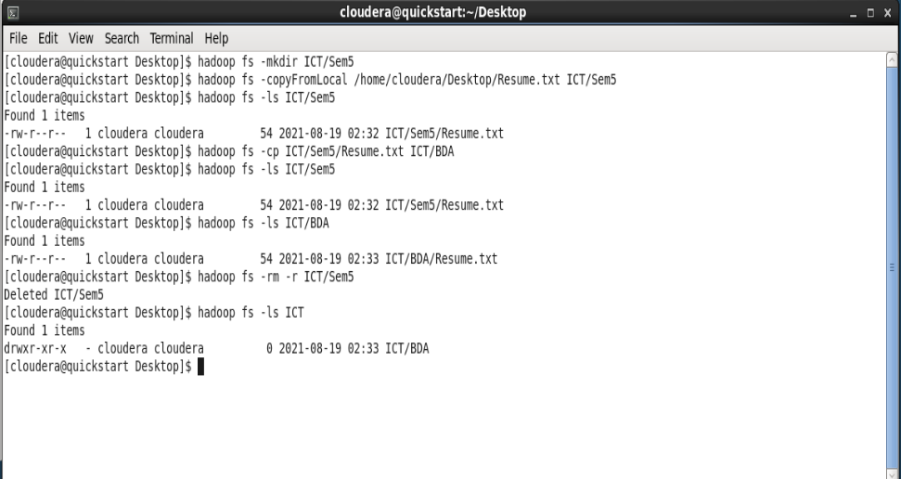

C. Check all above created file and directories size.

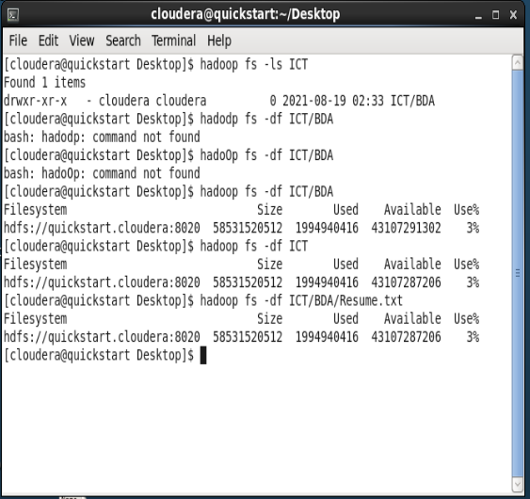

D. Check the total size of the directory.

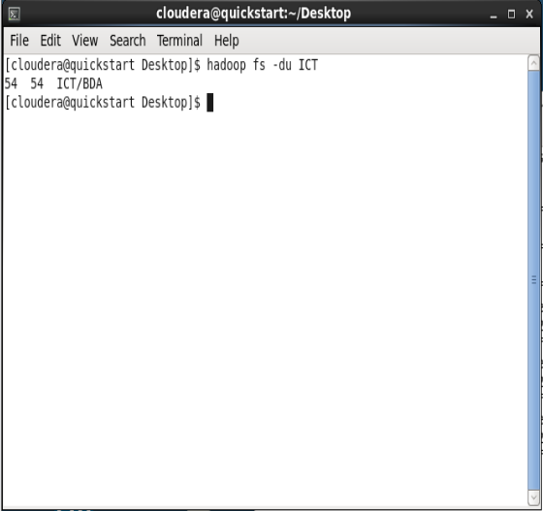

3. EXTRAS:

Also try the -setrep and the -chmod command.

